**Purpose**

A website that makes it easy for user to make hotel reservations close to a temple of their choosing. The website will achieve this by making the user have a temple feeling from its design and help its users to get affordable and uplifting reservation near the temple. The website will make it easy for to enjoy their stay by letting them know the offers they would get before arriving.

**Audience**

My targeted audience are those interested in visiting a temple of the church of Jesus Christ of later day saint and also wish to maintain an uplifting stay, like an extension of their temple experience to their reserved room.

Home

Temples

Reservations

Services

**Color Scheme**

**003D79 (59%)**

**Black**

**White**

**003D79**

**Color Scheme**

**Headings (Javanese Text)**



**WireFrames**

**Large**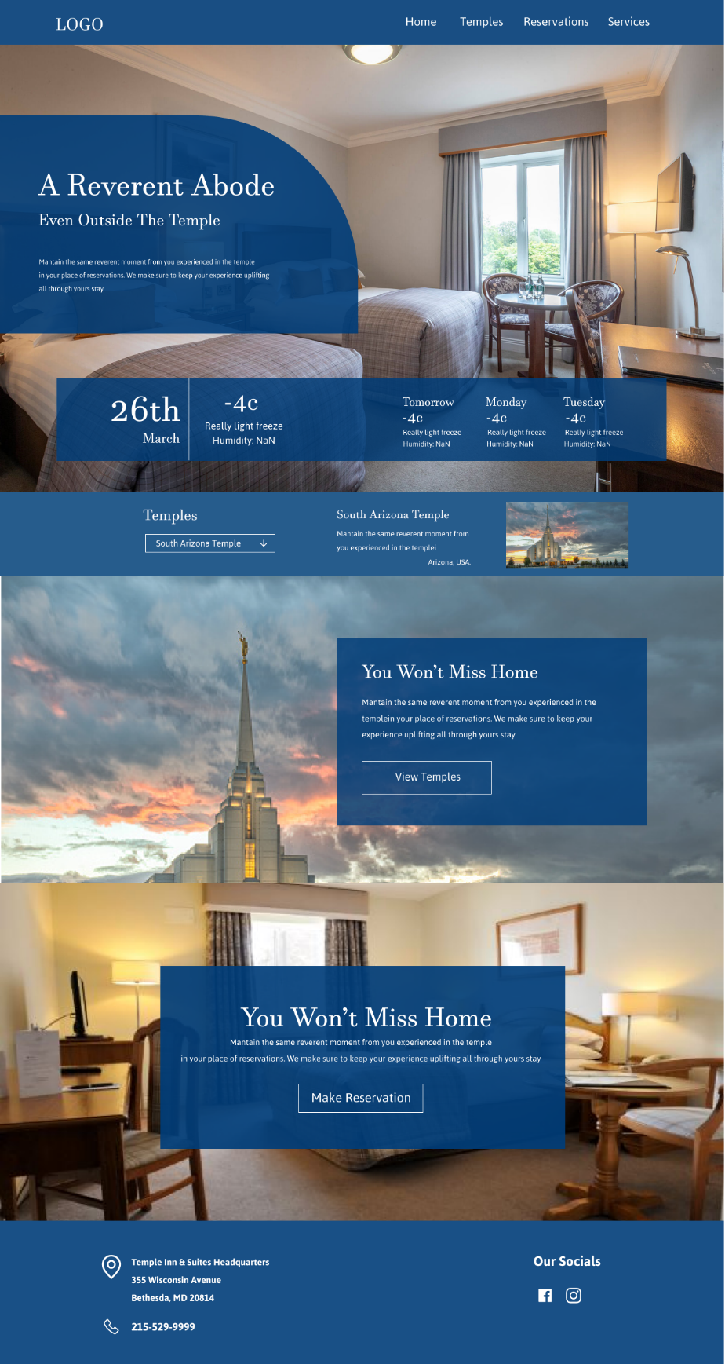

**Medium**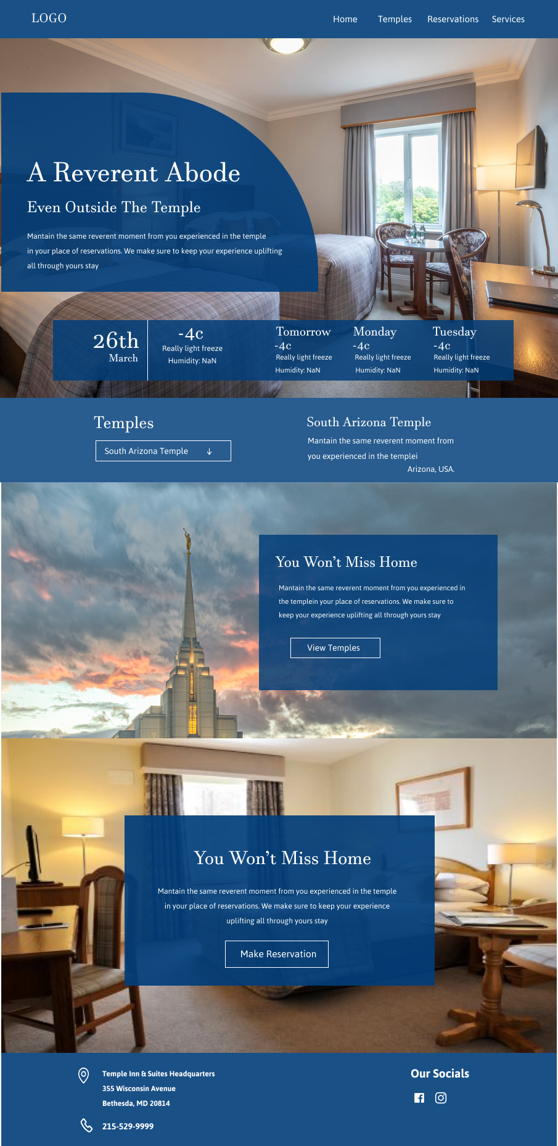

**Small** 